MONGOOSE – National Geographic

Map
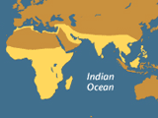
Mongoose Range

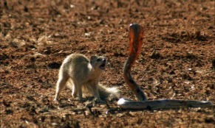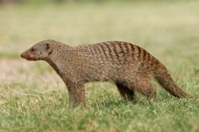

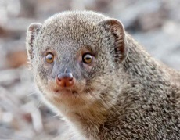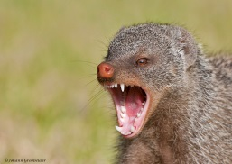

Fast Facts
Type:
Mammal
Diet:
Carnivore
Average life span in captivity:
20 years
Size:
Head and body, 7 to 25 in (18 to 64 cm); Tail, 6 to 21 in (15 to 53 cm)
Weight:
12 oz to 11 lb (340 g to 5 kg)
Did you know?
Mummified mongooses and images of the species have been discovered in ancient Egyptian tombs.

Mongooses are primarily found in Africa, their range covering most of the continent. Some species occupy parts of southern Asia and the Iberian Peninsula. They are generally terrestrial mammals, but some are semi-aquatic, and others are at home in the treetops.
Ranging in size from the 7-inch-long (18-centimeter-long) dwarf mongoose to the 2-foot-long (60-centimeter-long) Egyptian mongoose; these sleek mammals have long bodies with short legs and tapered snouts.
They normally have brown or gray grizzled fur, and a number of species sport striped coats or ringed tails.
Mongooses live in burrows and are nondiscriminatory predators, feeding on small animals such as rodents, birds, reptiles, frogs, insects, and worms. Some species supplement their diet with fruits, nuts, and seeds. Creative hunters, they are known to break open bird eggs by throwing them with their forepaws toward a solid object.
Famously, some species of mongoose will boldly attack venomous snakes such as cobras. The most celebrated of these is Rudyard Kipling’s fictional Rikki-tikki-tavi, based on an ancient fable and included in The Jungle Book.

In the 1800s mongooses were introduced to several islands in Hawaii and the West Indies in order to control the rodent populations on sugarcane plantations. Today this effort has come back to haunt these islands as mongooses threaten the survival of various native species, particularly birds. However, in their natural environments mongooses are currently threatened themselves due to habitat loss.

KING COBRA – National Geographic

Fast Facts
Status:
Vulnerable
Type:
Reptile
Diet:
Carnivore
Average life span in the wild:
20 years
Size:
13 ft (4 m)
Weight:
Up to 20 lbs (9 kg)
Group name:
Quiver
Did you know?
Synthetic cobra venom is used in pain relievers and arthritis medication.

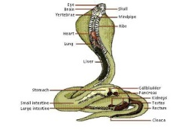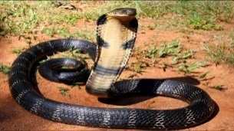

Size relative to a 6-ft (2-m) man:


It seems unfairly menacing that a snake that can literally "stand up" and look a full-grown person in the eye would also be among the most venomous on the planet, but that describes the famous king cobra.
King cobras can reach 18 feet (5.5 meters) in length, making them the longest of all venomous snakes. When confronted, they can raise up to one-third of their bodies straight off the ground and still move forward to attack. They will also flare out their iconic hoods and emit a bone-chilling hiss that sounds almost like a growling dog.
Venom
Their venom is not the most potent among venomous snakes, but the amount of neurotoxin they can deliver in a single bite—up to two-tenths of a fluid ounce (seven milliliters)—is enough to kill 20 people, or even an elephant. Fortunately, king cobras are shy and will avoid humans whenever possible, but they are fiercely aggressive when cornered.
Habitat and Behavior
King cobras live mainly in the rain forests and plains of India, southern China, and Southeast Asia, and their coloring can vary greatly from region to region. They are comfortable in the trees, on land, and in water, feeding mainly on other snakes, venomous and nonvenomous. They will also eat lizards, eggs, and small mammals.
They are the only snakes in the world that build nests for their eggs, which they guard ferociously until the hatchlings emerge.
King cobras may be best known as the species of choice for the snake charmers of South Asia. Although cobras can hear, they are actually deaf to ambient noises, sensing ground vibrations instead. The charmer's flute entices the cobra by its shape and movement, not by the music it emits.

